INTELLIGENT ADMISSIONS: THE FUTURE OF UNIVERSITY DECISION MAKING WITH MACHINE LEARNING

THE AIM OF THIS PROJECT IS TO HELP STUDENTS IN SHORT LISTING UNIVERSITIES WITH THEIR PROFILES.

INTRODUCTION

University admission is the process by which students are selected to attend a college or university. The process typically involves several steps, including submitting an application, taking entrance exams, and participating in interviews or other evaluations.

The aim of this project is to help students in short listing universities with their profiles. Machine learning algorithms are then used to train a model on this data, which can be used to predict the chances of future applicants being admitted.

***Project Flow:***

* ***User interacts with the UI to enter the input.***
* ***Entered input is analysed by the model which is integrated.***
* ***Once model analyses the input the prediction is showcased on the UI***

* ***To accomplish this, we have to complete all the activities listed below,***

***Define Problem / Problem Understanding***

* + ***Specify the business problem***
  + ***Business requirements***
  + ***Literature Survey***
  + ***Social or Business Impact.***
* ***Data Collection & Preparation***
  + ***Collect the dataset***
  + ***Data Preparation***
* ***Exploratory Data Analysis***
  + ***Descriptive statistical***
  + ***Visual Analysis***
* ***Model Building***
  + ***Training the model in multiple algorithms***
  + ***Testing the model***
* ***Performance Testing & Hyperparameter Tuning***
  + ***Testing model with multiple evaluation metrics***
  + ***Comparing model accuracy before & after applying hyperparameter tuning***
* ***Model Deployment***
  + ***Save the best model***
  + ***Integrate with Web Framework***
* ***Project Demonstration & Documentation***
  + ***Record explanation Video for project end to end solution***
  + ***Project Documentation-Step by step project development procedure***

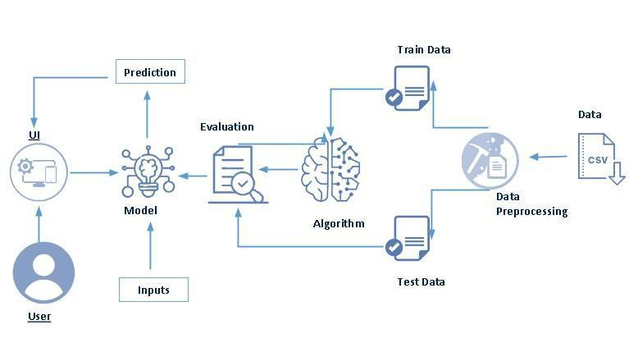 **Technical Architecture**

**CONCLUSION:**

**his analysis should also help students who are currently preparing or will be preparing to get a better idea**